McDonald’s Northern and Western Michigan All-Day Breakfast EDA Report
The Business Problem
For the past three years, McDonald’s franchises in Western and Northern Michigan have faced an annual decline of approximately 5% in customer traffic. Since this region generates around $200 million in annual revenue, this decline is a significant concern to the firm. To combat this trend, the region implemented an “all-day breakfast” promotion focusing on the McMuffin sandwich product line, which has a higher sales rate.
Based on the information provided, the region currently faces the following challenges:
- Should the region expand its current all-day offerings, maintain the status quo, or discontinue the promotion?
- The risk of cannibalization, where customers may choose the substitute higher-margin lunch and dinner products (e.g., Big Macs) for lower-margin breakfast items, potentially decreasing profitability, even if sales volumes have seemed to spike.
- Operational strains on franchisees due to producing breakfast, lunch, and dinner items simultaneously with the same equipment, creating logistical bottlenecks.
This analysis will delve into these challenges to determine the promotion’s true impact on sales revenue and profitability, ultimately aiming to address the issue of customer traffic.
Key Variables Related to the Issue
To determine the impact of the all-day breakfast (ADB) promotion, the analysis I conducted identified a few key variables. The variables in question allowed us to directly measure the core business problems that were outlined: declining customer traffic, potential sales cannibalization, and promotion menu expansion.
The most direct measure of customer traffic is the Average Daily Transactions (agc). An examination of this variable in Fig. 1.1 shows a distinct seasonal pattern, with a noticeable dip around the December-January period each year. While sales steadily increase in the following months, the ADB promotion does not appear to have significantly boosted this rise in 2016, as the overall trend line continues to slope downward, as seen below. This suggests that while seasonal peaks do occur, the ADB promotion has not, on its own, been sufficient to reverse this decline in customer traffic. In terms of this variable’s reliability for our analysis, its completeness across the dataset with no significant missing values suggests that this variable is suitable for analysis.
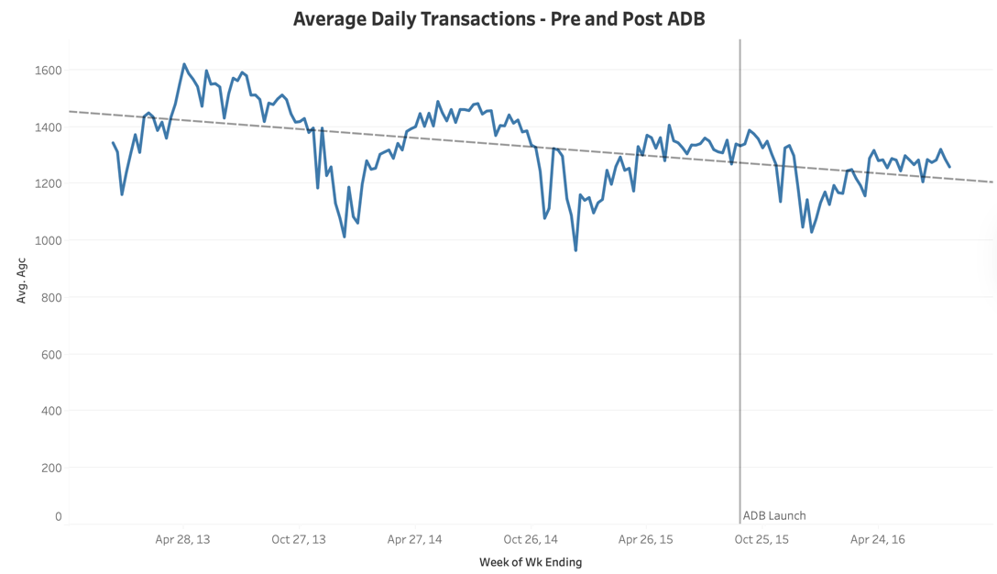
Fig 1.1
On the other hand, to understand how customer preferences have changed, I analyzed the Product Sales Mix by grouping products into "Breakfast" and "Lunch & Dinner" categories and tracking their weekly units sold (urws) across time (Fig. 1.2). My sales mix analysis showcases that before the promotion, breakfast items made up about 20% of total sales. After the launch, their share peaked near 30% before stabilizing around 25%, directly correlating to a drop in the lunch & dinner share. This directly addresses the manager's concern about cannibalization, confirming that the promotion caused a somewhat significant shift in sales from lunch and dinner items to breakfast items. To ensure accuracy, my analysis exclusively uses the weekly units sold field for all sales volume calculations.
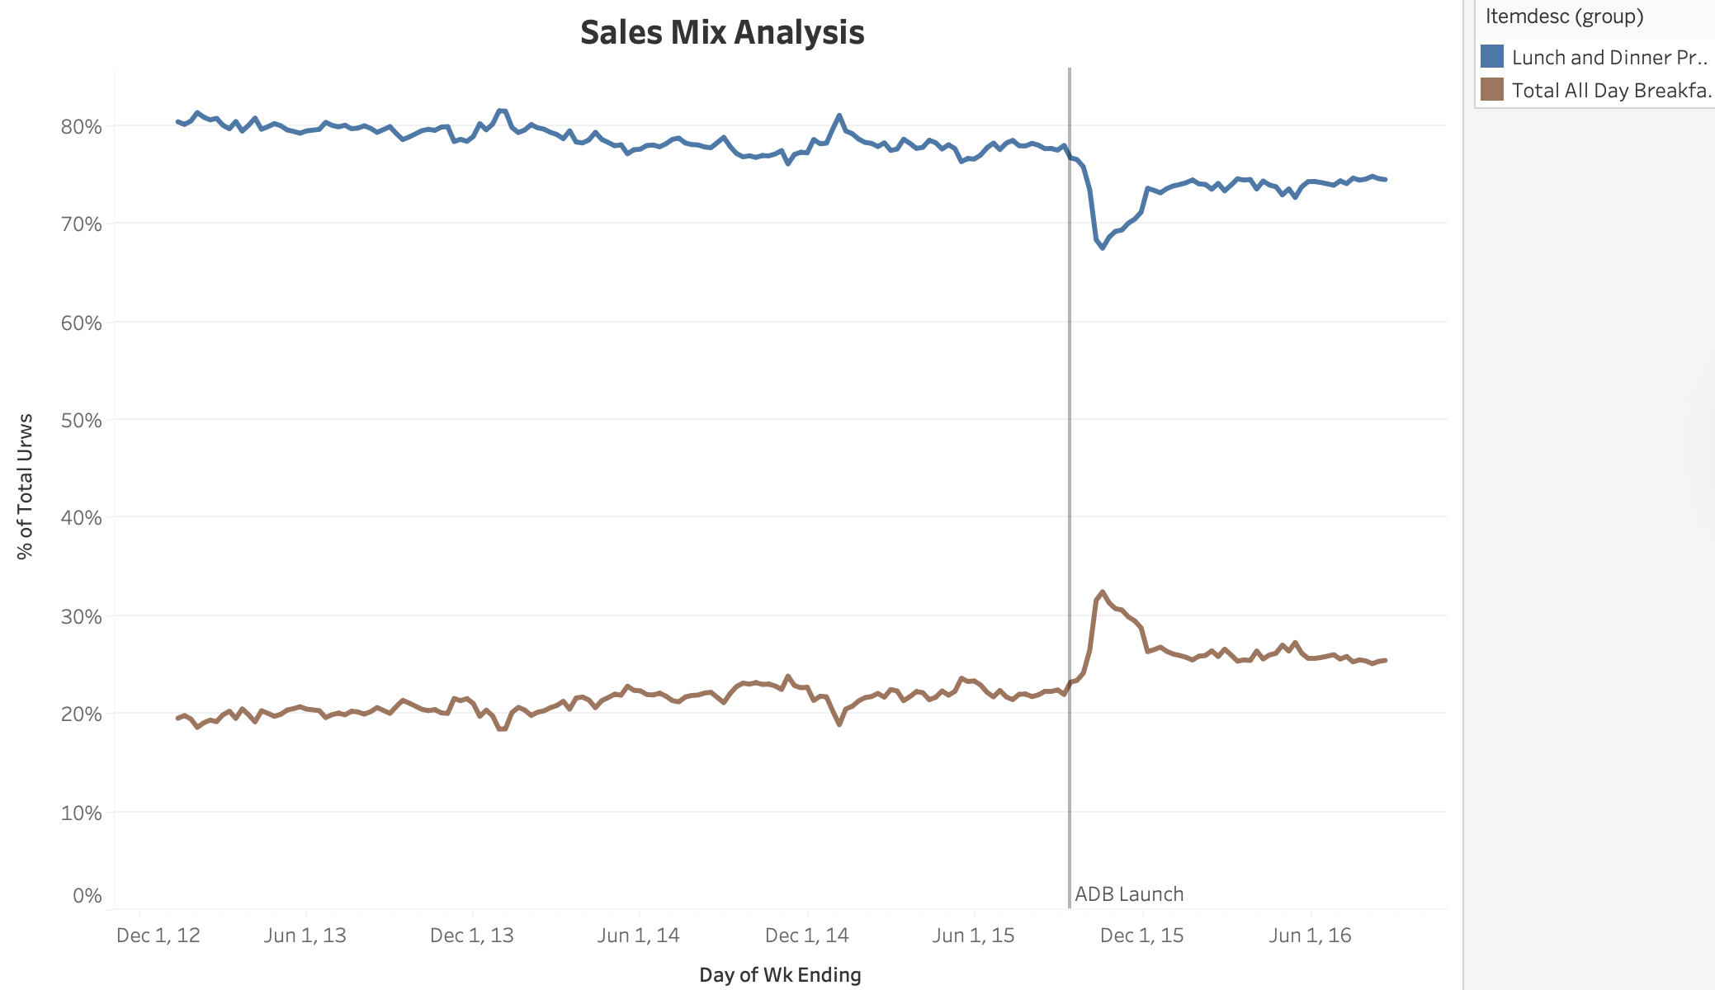
Fig 1.2
Finally, I explored the relationship between Price and Sales Volume (wavg_price vs urws) to determine whether it was worth expanding the ADB menu offerings. The scatterplot visualization, as seen in Fig. 1.3, shows that as price increases, sales volume tends to decrease. It also revealed that aside from the Hashbrown, McMuffin products generated significantly higher sales compared to other breakfast items, such as McGriddles or biscuits. These results suggest that, aside from the Hashbrowns, there aren’t really any other breakfast items worth adding to the ADB menu and that focusing on the McMuffin offerings would be more effective for the firm.

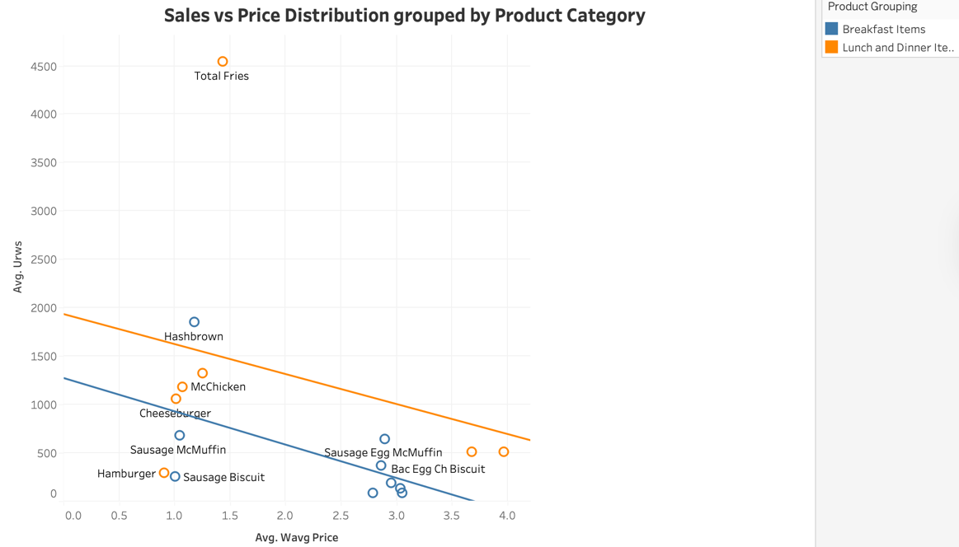
Fig 1,3
Data Quality Concerns
An examination of the dataset's quality and integrity revealed several issues. Firstly, an analysis of sales trends for each franchise over time (Fig. 1.4) revealed random, sharp dips in sales for certain locations, suggesting that sales data was not recorded for some weeks. While infrequent, these gaps could skew long-term trend and forecast calculations if not handled correctly. Secondly, for some locations, the historical sales data does not begin in 2013 (Fig. 1.5). This likely means these franchises opened on later dates, but it could also indicate that early data is missing. Finally, demographic information, specifically the income level of a franchise’s area, is missing for certain locations, which limits our ability to analyze how customer income levels might impact the promotion’s success (Fig. 1.6).
Hypotheses
Based on the exploration of the dataset conducted above, several hypotheses can be formed regarding how this data can be used to provide clear, data-driven recommendations.
The first hypothesis is that we can use average daily transactions (agc) to clearly measure the promotion’s effect on customer traffic. Although some exploratory analysis on this was conducted earlier, a more detailed breakdown will allow us to quantify this change. For example, while the initial time-series analysis does provide us some insight, a decomposition analysis will allow us to mathematically separate the promotion’s effect from factors like seasonality. This, in turn, will provide a clearer picture as to whether the ADB promotion is truly reversing the declining customer traffic.
The other hypothesis is to further segment ADB performance by store type, as shown in the analysis below. This initial analysis (Fig. 1.7 in the appendix) revealed that storefront locations experienced minimal changes in ADB sales compared to freestanding and special locations. Using this data, we can more accurately test whether a franchise’s physical format and operational model impact ADB sales. If the hypothesis is confirmed, the firm could refine its regional strategy accordingly.
Is the data sufficient?
The data currently provided is sufficient for preliminary analysis and to make initial recommendations regarding the ADB promotion. However, while some key variables, such as average guest count (AGC) and weekly units sold (URWS), are nearly 100% complete, other data quality issues, such as random dips in sales for certain locations and the absence of demographic information, make a more robust and in-depth analysis difficult. Additionally, without specific profit margin data for each product, conducting a full profitability analysis of the promotion is not feasible. Moreover, since my primary methodological assumption is that this promotion is the most significant factor in reversing the decline in customer traffic, having sales-by-time-of-day data would help confirm whether customers are indeed purchasing breakfast products outside of traditional breakfast hours. In conclusion, while the available data is sufficient to perform some meaningful analysis, additional and higher-quality data are required to gain a clearer understanding of the promotion’s overall impact.

References
Google. (2024). Gemini (Large language model). [Grammar and style review]. https://gemini.google.com
Appendix
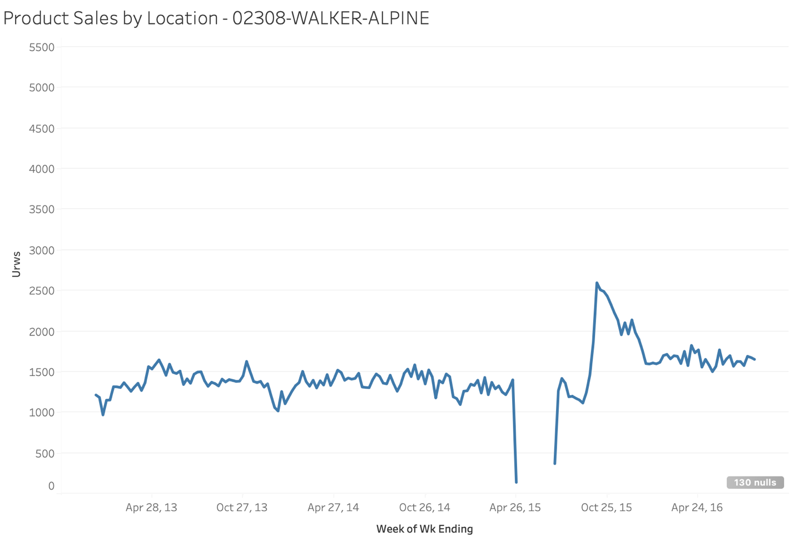
Fig 1.4
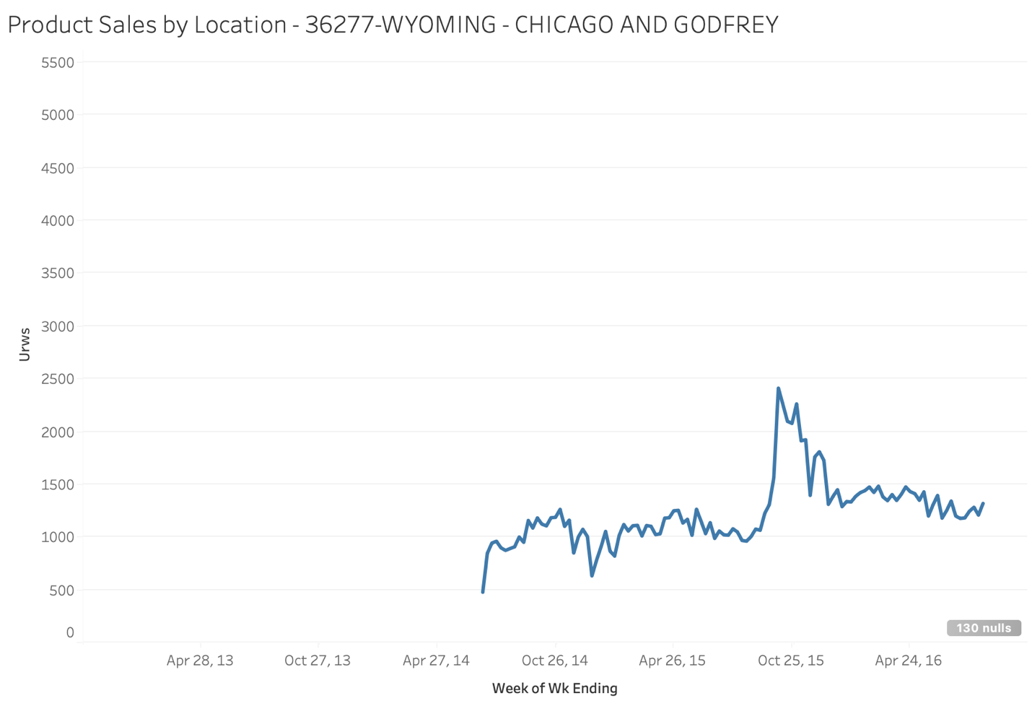
Fig 1.5
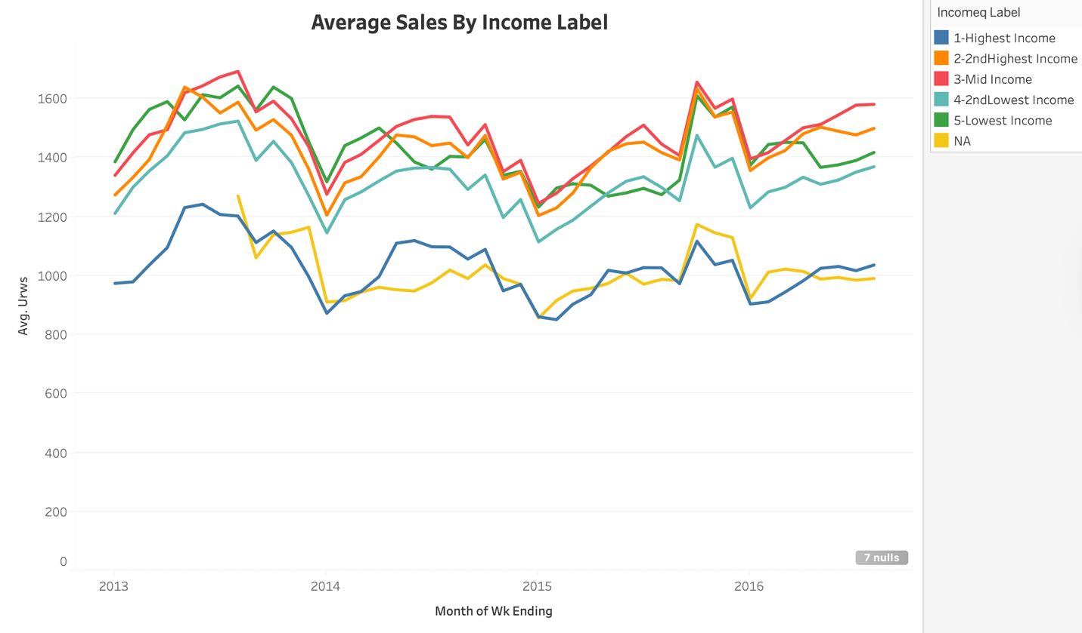
Fig 1.6
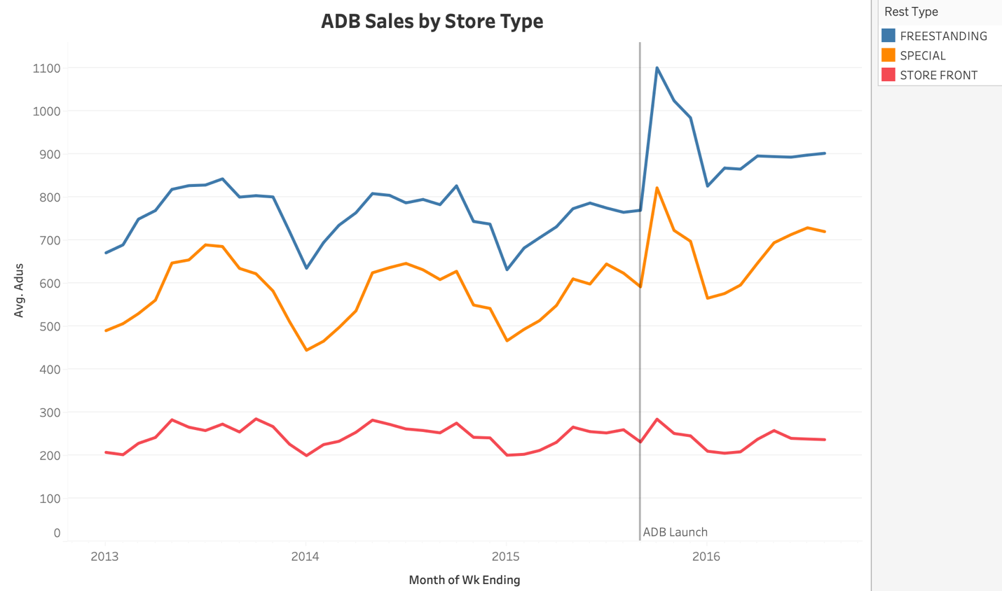
Fig 1.7

